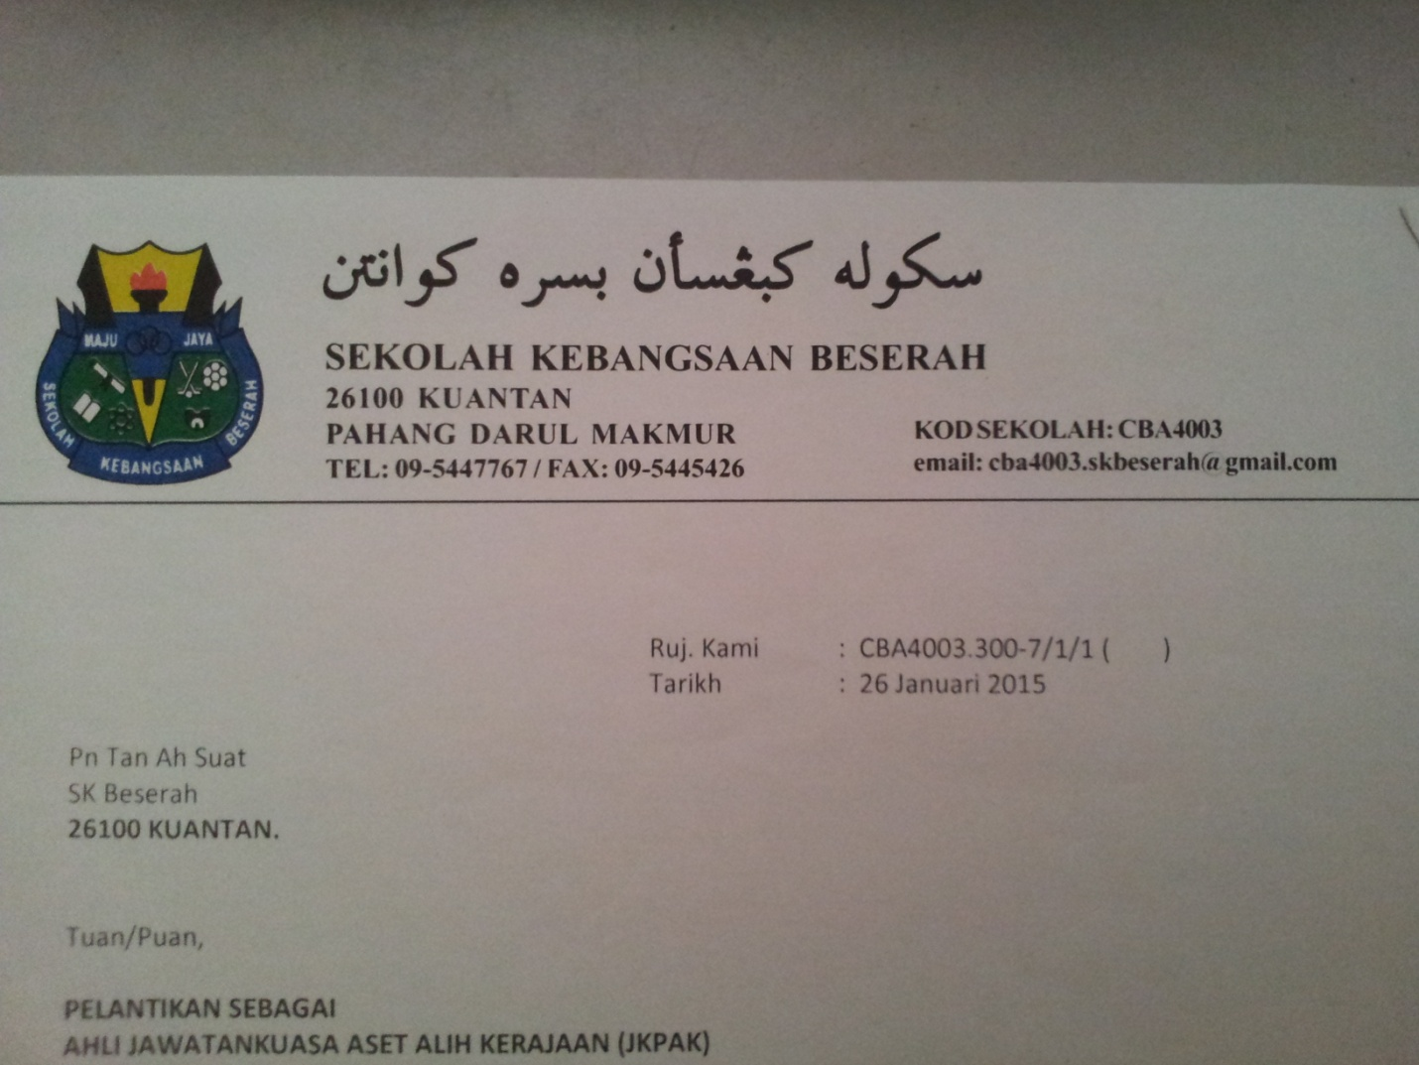

To whom it may concern,

I, Narulhuda binti Yaacob, would like to declare that I have tested the Beserah Primary School English Club management system designed and programmed by Hor Sui Lyn, NRIC number 960801065858, as her CIE A-Levels 9691 Computing Paper 4 Project.

2. The system has been tested with realistic data and it ran and performed successfully and up to standard.

3. The on-screen help, which is a part of the software, was user-friendly and useful as it provides guide stepwise until the problem was solved.

4. I have also viewed and looked through the implementation plan and agreed to carry out the proposals suggested by Hor Sui Lyn after careful considerations.

5. Therefore, I, Narulhuda binti Yaacob, as the Head of English Panel and the Chief Advisor of English Club of Beserah Primary School, Kuantan, Pahang, would like to highlight that the testing and implementation plan of this system has been carried out successfully and to my satisfaction with the help of Hor Sui Lyn.

___________________

(Narulhuda binti Yaacob )



To whom it may concern,

I, Narulhuda binti Yaacob, hereby declare that Hor Sui Lyn, NRIC number 960801065858, has done a splendid job designing and producing a school club management system for us for her CIE A-Levels 9691 Computing Paper 4 Project.

2. The proposed programme, which fulfills all the objectives and requirements agreed upon, has functioned smoothly as expected.

3. Therefore, I, Narulhuda binti Yaacob, as the Head of English Panel and the Chief Advisor of English Club of Beserah Primary School, Kuantan, Pahang, would like to express our sincere gratitude to Hor Sui Lyn on behalf of the English Club, for her sacrifice in spending her time and energy in designing this system for us.

___________________

( Narulhuda binti Yaacob )